# VBA Homework Output

This file will show the screen shots of the following in 2016, 2015, and 2014.

1. Stock Summary – Results of Price Change, Percentage Change and Total Stock Volume by Stock Ticker
2. Challenge Summary – Results of Greatest Percentage Increase, Greatest Percentage Decrease and Greatest Total Stock Volume from the Stock Summary Table generated above.

To see all the results, please refer to file in the Github Link:

* **Github Link**: https://github.com/cecileung1208/VBA-challenge/Results
* **File Name**: Unit 2 -VBA_Homework_Instructions_Resources_Multiple_year_stock_data – Final.xlsm

# Stock and Challenge Summary

Stock Summary Table is in columns J to K.

Stock Challenge Table is in columns O to Q.

## 2016

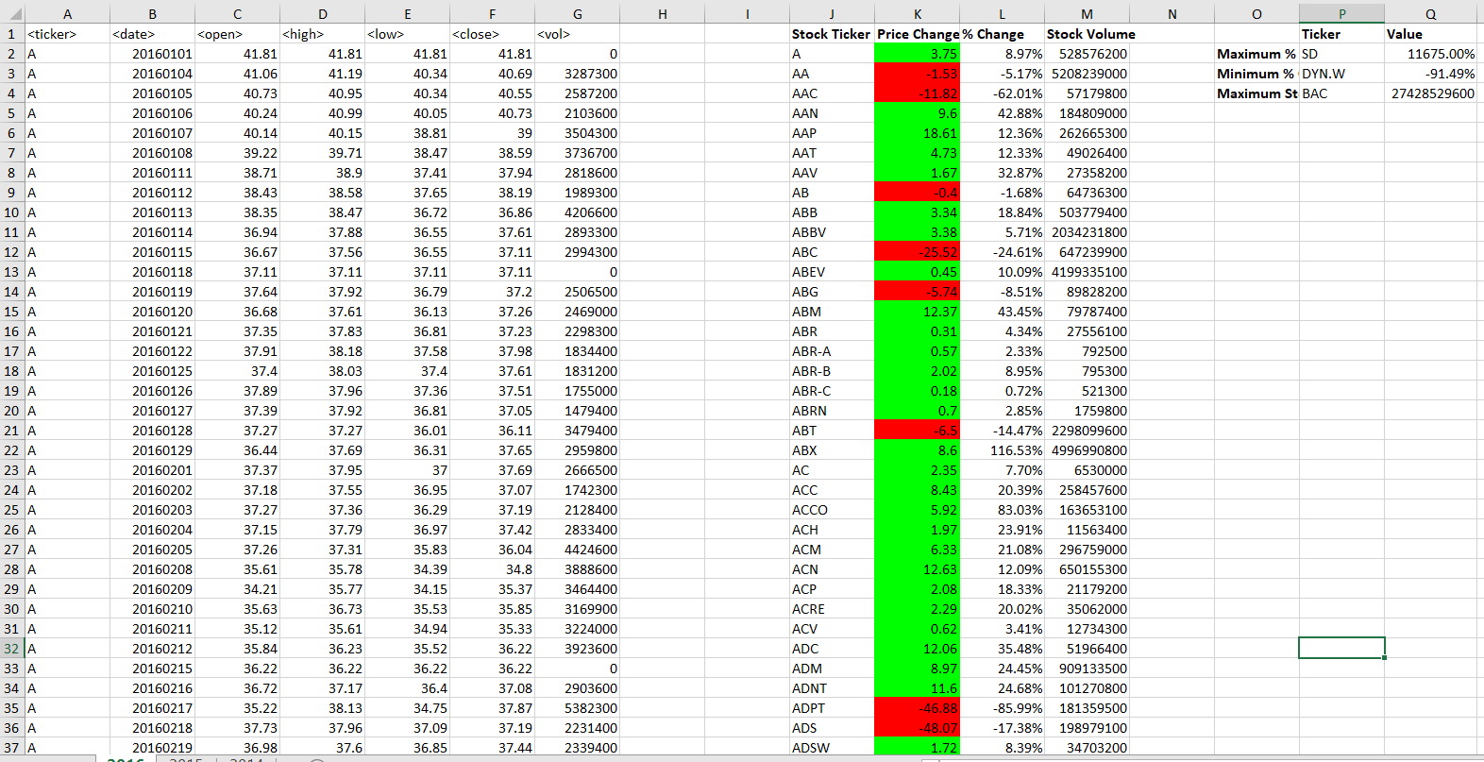

## 2015

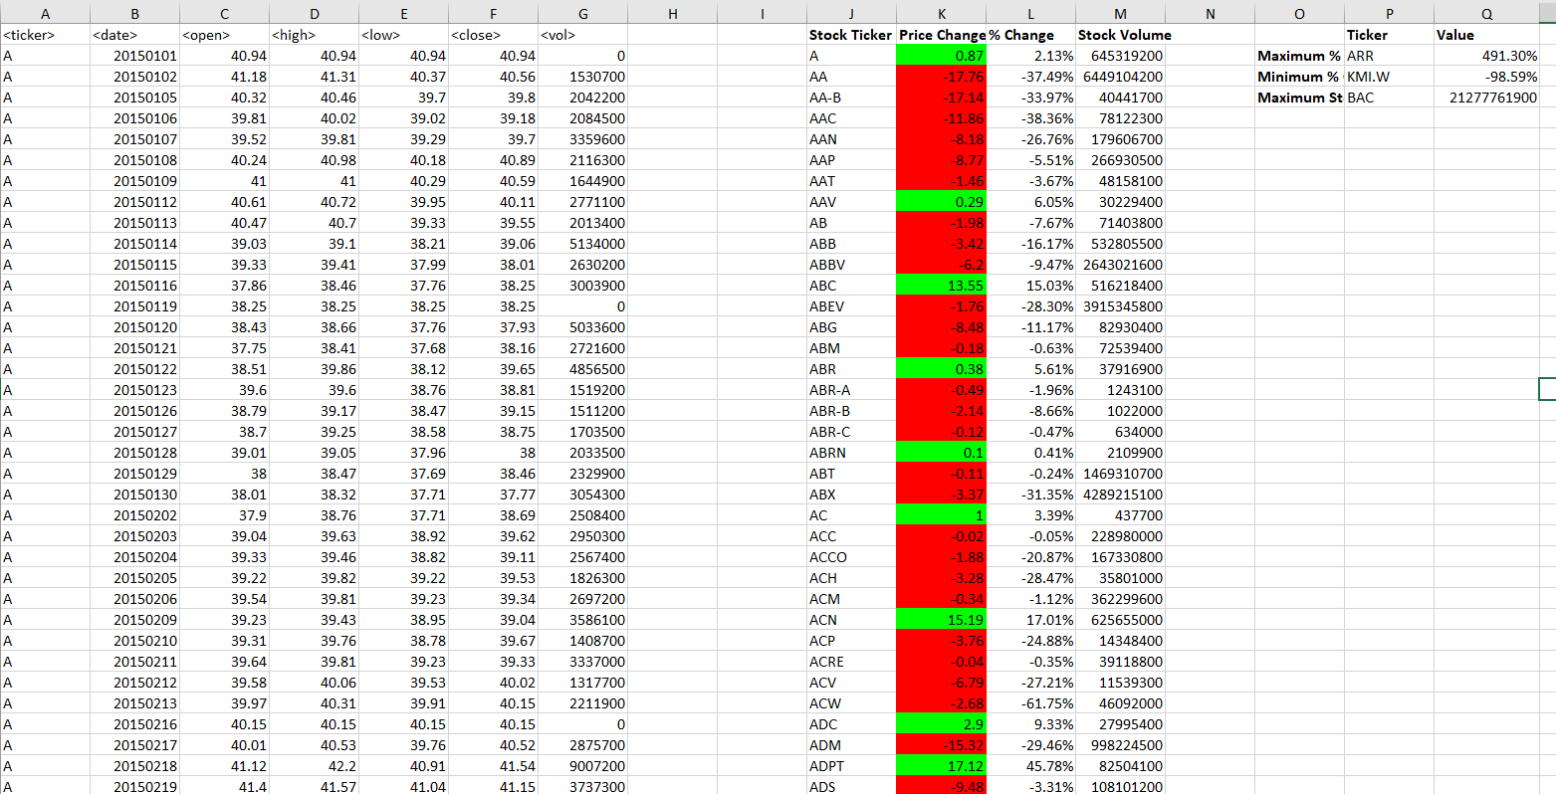

## 2014

